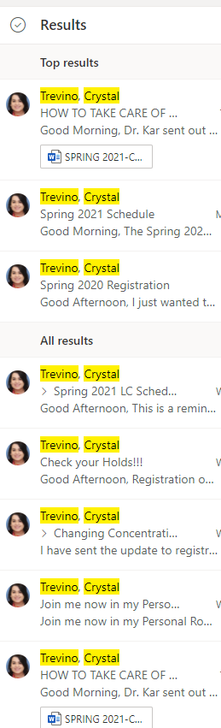I talked with my counselor more in depth about my schedule and signed up for classes. I felt prepared and was able to do this with almost no stress. I helped one of my groupmates on Friday sigh up for his classes. How smooth this prosses was for me compared to some of my friends made me realize the importance of getting ready before hand. This was a lot less stressful than it was the first time signing up for classes and I will repeat the prosses so I can once again sign up for classes in the future stress free.